Artificial Intelligence in Manufacturing:
Case Study Research and Innovation Proposal
Student Name: Tiara Scott
Course: ITAI 2372
Date: April 20, 2026

Introduction
Artificial intelligence (AI) is now a core enabler of modern manufacturing. Manufacturers use it to analyze machine signals, automate inspection, forecast supply risks, and support decisions on the factory floor. Industry groups and analysts increasingly treat AI as part of smart manufacturing because connected systems, analytics, and automation can improve agility and productivity when implemented well (Deloitte, 2025; NAM, 2024).
AI matters in manufacturing because plants face expensive downtime, labor and skills shortages, and pressure to reduce waste and emissions. Deloitte’s 2025 smart manufacturing survey notes that while value is becoming clearer, companies still face transformation complexity, operational risk, cybersecurity concerns, and the need for workforce upskilling (Deloitte, 2025).
This report examines a real-world implementation of AI in the manufacturing sector: BlueScope Steel’s use of Siemens Senseye Predictive Maintenance. The case is especially useful because it illustrates not only technical deployment, but also organizational change from reactive to proactive maintenance. After analyzing the case, the report proposes a new AI application for manufacturing: an AI-driven energy orchestration system for energy-intensive plants. The proposal aims to show how AI can move beyond reliability and quality into a strategic sustainability and cost-optimization role.

Case Study Analysis: BlueScope Steel and Siemens Senseye Predictive Maintenance

Background and problem addressed
BlueScope is a global steel manufacturer whose operations include complex, continuous-process production lines. In this environment, maintenance problems are unusually costly because failures can interrupt production, create restart losses, generate waste, and expose workers to difficult maintenance conditions. Siemens notes that steel production involves scale, complexity, harsh operating conditions, and the challenge of coordinating maintenance without disrupting production; in continuous plants, unplanned outages can cost millions in lost production and restart costs (Siemens, n.d.-a).
BlueScope’s core challenge was that traditional maintenance methods were too reactive. Before the new system, at least some equipment conditions were monitored mainly through visual checks and simple threshold devices, which could miss gradual deterioration. That meant small faults could escalate into major stoppages, safety hazards, and manual recovery work. The company therefore sought a way to plan maintenance proactively, reduce both planned and unplanned downtime, and strengthen global competitiveness (Siemens, n.d.-a; Siemens, 2025a).

AI technologies and tools used
BlueScope selected Siemens Senseye Predictive Maintenance, a software-as-a-service platform that combines industrial data collection with AI-driven analytics. The system ingests machine and sensor data such as pressure, current, vibration, temperature, and other condition indicators, then uses machine learning to detect anomalies, recognize patterns, forecast risk, and in some cases estimate remaining useful life (Siemens, 2024a; Siemens, 2023).
A key feature of Senseye is that it does not require a detailed digital twin for every asset. It can learn from machine data and maintainer feedback, then rank alerts through its Attention Index based on patterns, prior alerts, asset criticality, user feedback, and production context. In practice, this helps maintenance teams focus on the alerts that matter most rather than simply receiving more alarms (Siemens, 2023).
BlueScope’s deployment began with a 12-month pilot at Springhill Works in Port Kembla, where 300 units were commissioned across three metal coating lines. The pilot was considered highly successful after only seven months, which helped BlueScope scale the program globally. Later enhancements incorporated generative AI functions that could group cases, find similar past cases, process information from multiple maintenance systems, and present insights through a conversational interface. According to Siemens, this was designed to make decision-making faster while protecting customer data within a private cloud environment and not using it to train external models (Siemens, n.d.-a; Siemens, 2024b).
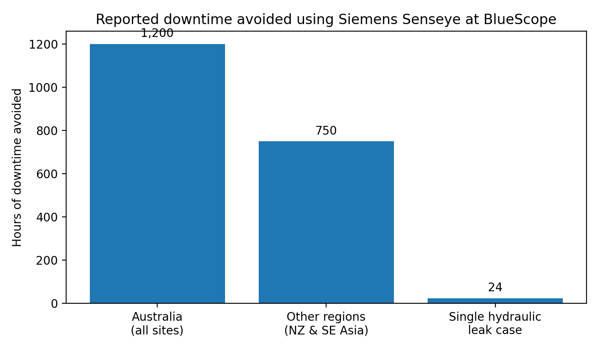
Figure 1. Reported downtime avoided in BlueScope’s Senseye deployment. Data summarized from Siemens company materials.

Outcomes and benefits achieved
The reported outcomes are substantial. Siemens states that BlueScope has avoided about 2,000 hours of unplanned downtime across three years since 2022, including more than 1,200 hours in Australia and more than 750 hours across New Zealand and Southeast Asia. The company also reports preventing 53 complete process interruptions globally (Siemens, 2025a; Siemens, n.d.-a).
At the incident level, Siemens describes one hydraulic leak on a metal coating line that was detected early through a gradual pressure drop. Senseye generated a predictive warning, allowing the BlueScope team to fix the issue during a scheduled maintenance window. That single intervention avoided at least 24 hours of unplanned downtime and also prevented dangerous manual intervention and the costly rethreading of steel strip into the line (Siemens, n.d.-a).
Benefits extended beyond uptime. BlueScope linked predictive maintenance to less waste, fewer delays, and lower emissions because maintenance could be performed without unnecessary stoppages. Siemens also reports that Senseye clients across live deployments have achieved an 85% improvement in downtime forecasting accuracy, a 50% reduction in unplanned downtime, a 55% increase in maintenance staff productivity, and a 40% reduction in maintenance costs, with payback in under three months (Siemens, 2024a). These figures are portfolio-level, not BlueScope-specific, but they help explain the business case for expansion.

Implementation challenges and risks
The case also reveals several implementation challenges. The first was scale: BlueScope moved from a pilot to a multi-site rollout across a global footprint, which required consistent data flows, governance, and integration across different plants and equipment types (Siemens, n.d.-a; Siemens, 2023).
A second challenge was data heterogeneity. Industrial environments often rely on legacy machines, retrofitted sensors, historians, controllers, and separate maintenance software. Siemens identifies data silos, low adoption, collaboration gaps, and skills shortages as central barriers to predictive-maintenance success, while Deloitte highlights transformation risk, cybersecurity, and talent limits as broader smart-manufacturing concerns (Siemens, 2024c; Deloitte, 2025).
A third risk concerns organizational trust and use. AI systems create value only when maintenance teams act on alerts and incorporate the system into everyday decisions. BlueScope’s success suggests that the company managed this cultural shift well, but it remains a significant implementation risk in many factories. Too many false alerts, poor explainability, or weak process ownership can lead teams to ignore the system. For that reason, Senseye’s user-feedback model and later generative-AI interface are strategically important: they do not replace human expertise, but instead surface and scale it (Siemens, 2023; Siemens, 2024b).
Overall, the BlueScope case demonstrates that AI can deliver measurable operational value in manufacturing when the problem is well-defined, the data pipeline is strong enough, and the implementation is treated as both a technical and cultural transformation.

Proposal for Innovation: AI-Driven Energy Orchestration for Energy-Intensive Manufacturing
A promising next step for AI in manufacturing is not just predicting failures, but dynamically orchestrating plant energy use. I propose an AI-driven energy orchestration system for energy-intensive sectors such as steel, cement, glass, chemicals, and food processing. The purpose would be to reduce energy waste and carbon intensity while maintaining throughput, product quality, and equipment health.
The proposed system would combine several AI capabilities. A forecasting layer would predict short-term electricity demand, thermal demand, and equipment loading from plant data. A second layer would ingest external signals such as utility tariffs, weather, and renewable forecasts. A third layer, using reinforcement learning or optimization, would recommend or automatically schedule energy-intensive tasks, start-up sequences, compressor loads, HVAC settings, or battery use within quality and safety limits.
This proposal is novel in a practical sense because many manufacturers already monitor energy, but far fewer coordinate energy use at the plant level in real time. Most systems are descriptive dashboards. By contrast, an orchestration system would be prescriptive: it would recommend what to run, when to run it, and how to shift loads across equipment and time.
The logical benefits are strong. First, energy is a major controllable cost in manufacturing, especially in heavy industry. Second, inefficient energy use often overlaps with other forms of waste, such as idle running, repeated heating and cooling cycles, suboptimal sequencing, and emergency production changes. Third, better orchestration can support sustainability targets by lowering emissions per unit produced, especially when grid carbon intensity varies over the day. Fourth, the same platform could reduce wear on assets by avoiding unnecessary peak loading, thereby complementing predictive maintenance rather than competing with it.
The proposal would also produce managerial benefits. Supervisors would gain a clearer view of trade-offs among throughput, cost, quality, and carbon. Maintenance teams could receive warnings when energy-driven operating patterns begin to stress assets. In other words, the application would connect production, maintenance, and utilities instead of optimizing them separately.
However, the anticipated challenges are serious. The system must optimize cost, quality, output, and safety at the same time. It would require integration across energy, process, and utility data, strong cybersecurity, and operator trust. Management would also need clear rules for when AI can recommend actions, when it can act automatically, and when human approval is required.
Despite these difficulties, the proposal is highly practical. Manufacturers are already under pressure to cut costs, improve resilience, and meet sustainability goals. An AI-driven energy orchestration system addresses all three. In sectors where margins are sensitive to utility prices and downtime risks are high, even modest percentage reductions in energy cost or waste can translate into large annual savings. For that reason, this application is a credible next-generation use case for industrial AI.

Conclusion
AI is reshaping manufacturing by turning industrial data into operational decisions. The BlueScope case shows this clearly. By implementing Siemens Senseye Predictive Maintenance, BlueScope moved from reactive maintenance toward a proactive, data-driven approach. The result was measurable value: avoided downtime, fewer process interruptions, lower waste, and a strong basis for global rollout.
The case also shows that successful AI implementation is not only about algorithms. It depends on data integration, scalable deployment, user trust, workforce readiness, and governance. These lessons matter for any manufacturer considering AI adoption.
Building on those insights, the proposed AI-driven energy orchestration system offers a logical next frontier. Where predictive maintenance protects uptime, energy orchestration would improve both profitability and sustainability by coordinating when energy-intensive operations run. Together, these examples suggest that the most valuable manufacturing AI applications combine technical intelligence with operational realism.

References
Deloitte. (2025, May 1). 2025 smart manufacturing survey. Deloitte Insights.
National Association of Manufacturers. (2024, May 1). AI in manufacturing.
Siemens. (2023). Predictive maintenance is about more than algorithms.
Siemens. (2024a). The true cost of downtime 2024.
Siemens. (2024b, February 7). Siemens elevates predictive maintenance with innovative generative AI.
Siemens. (2024c). Senseye Predictive Maintenance (product brochure).
Siemens. (2025a, September 4). BlueScope saves ~2,000 hours of downtime with predictive maintenance technology.
Siemens. (n.d.-a). BlueScope’s predictive leap with Senseye.

